Experiment 8: Installing Cassandra on Ubuntu WSL
Objective
To install and configure Apache Cassandra on Ubuntu WSL using Docker, create a keyspace and tables, insert sample data, and execute CQL queries for efficient data retrieval.
Procedure
- Install Ubuntu WSL and update the system.
- Install Docker on Ubuntu WSL.
- Create a project directory.
- Create a docker-compose.yml file for Cassandra.
- Start the Cassandra Docker container.
- Verify that Cassandra is running.
- Connect to Cassandra using cqlsh.
- Create a keyspace named sparkify.
- Create tables for storing music streaming data.
- Insert sample records into the tables.
- Execute CQL queries to retrieve the required data.
- Verify the results and exit Cassandra.
Code
1. Create Project Directory
mkdir -p ~/cassandra-exercise
cd ~/cassandra-exercise
2. Create docker-compose.yml
services:
cassandra:
image: cassandra:latest
container_name: cassandra
hostname: cassandra
ports:
- "9042:9042"

environment:
CASSANDRA_CLUSTER_NAME: MyCluster
CASSANDRA_DC: datacenter1
CASSANDRA_RACK: rack1
volumes:
- ./cassandra-data:/var/lib/cassandra
restart: unless-stopped
3. Start Cassandra
docker compose up -d
4. Verify Container
docker ps
5. Connect to Cassandra
docker exec -it cassandra cqlsh
6. Create Keyspace
CREATE KEYSPACE sparkify
WITH REPLICATION = {
'class':'SimpleStrategy',
'replication_factor':1
};
7. Use Keyspace
USE sparkify;
8. Create Table
CREATE TABLE song_info_by_session (
session_id INT,
item_in_session INT,
artist TEXT,
song TEXT,
length DECIMAL,
PRIMARY KEY (session_id, item_in_session)
);
9. Insert Dat
INSERT INTO song_info_by_session
(session_id,item_in_session,artist,song,length)
VALUES
(100,1,'The Beatles','Hey Jude',7.11);

INSERT INTO song_info_by_session
(session_id,item_in_session,artist,song,length)
VALUES
(100,2,'Led Zeppelin','Stairway to Heaven',8.02);
10. Retrieve Data
SELECT * FROM song_info_by_session
WHERE session_id=100;
11. Exit Cassandra
EXIT;

Part 1: Installing Cassandra on Ubuntu WSL
Check WSL Setup
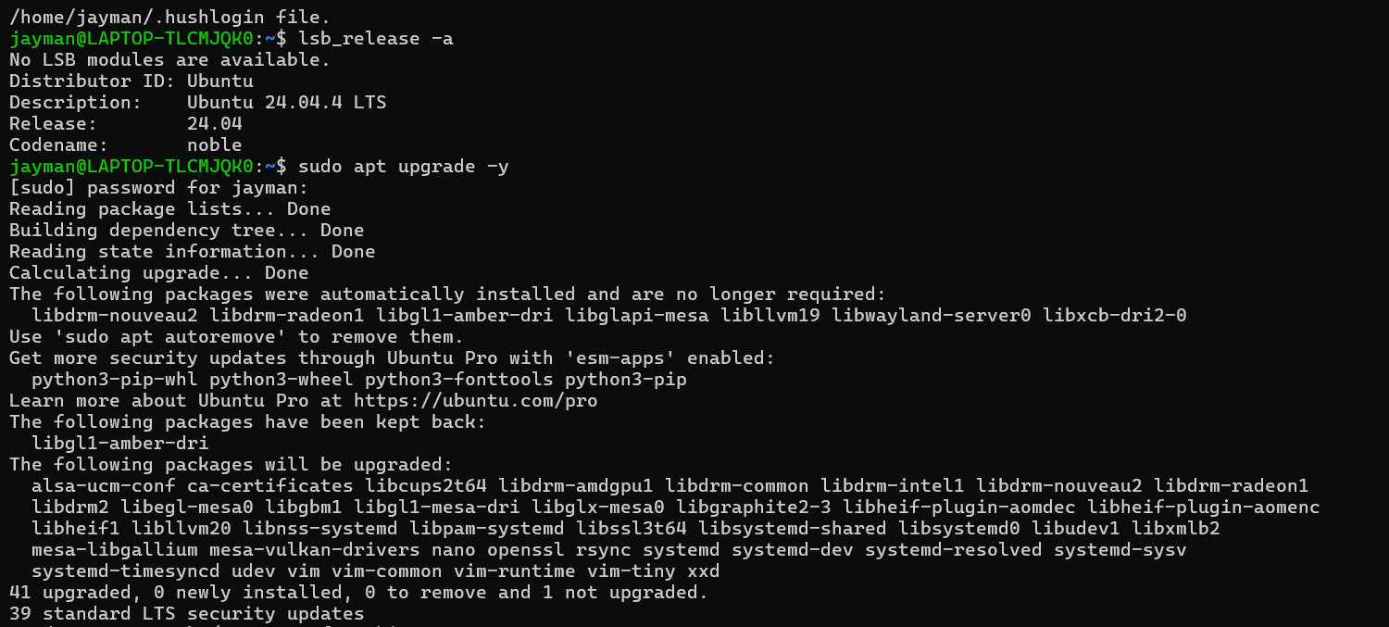

Step 1: Install Docker on WSL
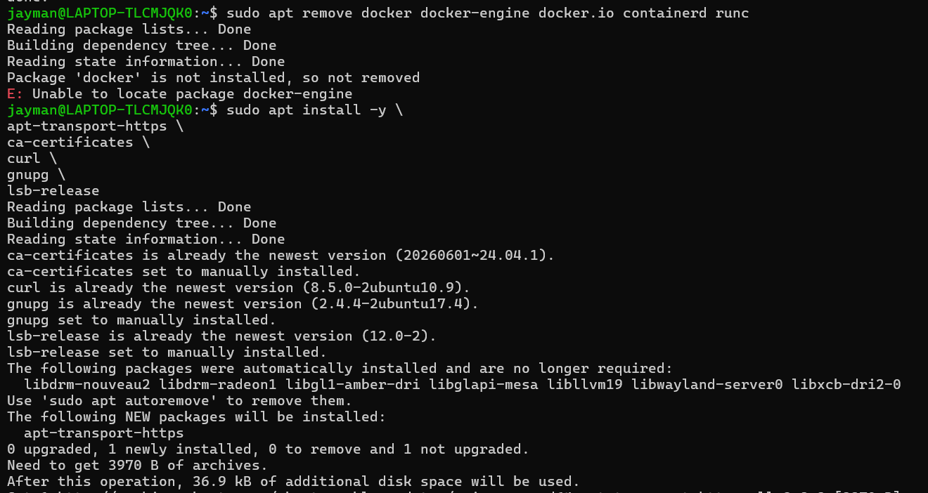
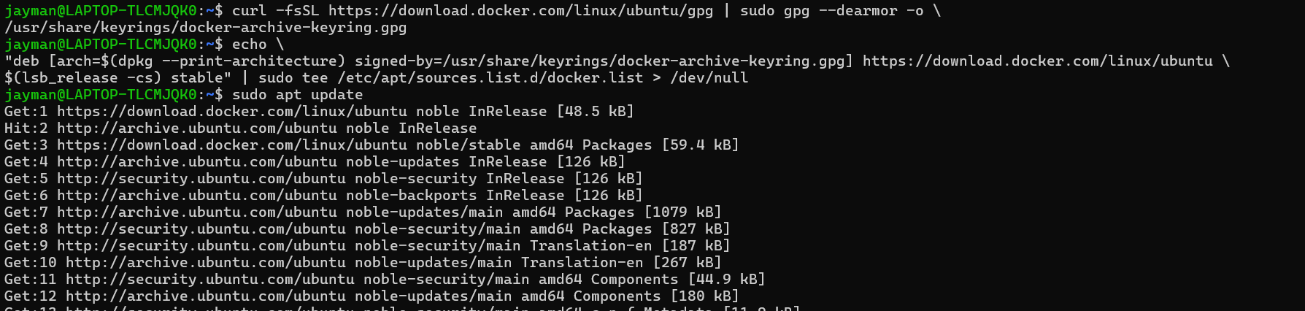
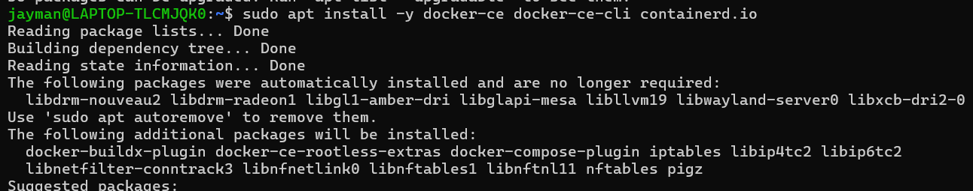

Step 2: Start Cassandra with Docker
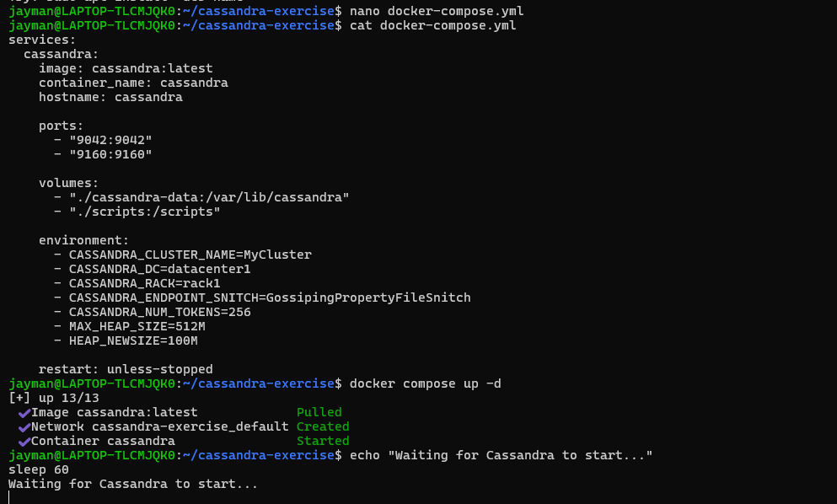
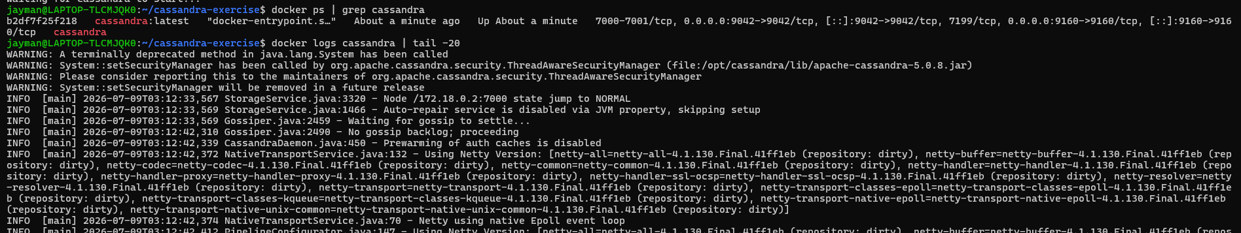
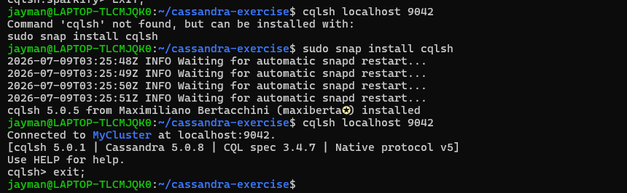
Conclusion
Apache Cassandra was successfully installed and configured on Ubuntu WSL using Docker. A keyspace and table were created, sample records were inserted, and CQL queries were executed successfully. This experiment demonstrates Cassandra's ability to efficiently store and retrieve large-scale distributed data using a query-driven data model.

